**Biden should defend Black cities having their power stripped by white outsiders**

[**Link to Article**](https://www.msnbc.com/opinion/msnbc-opinion/bidens-position-dc-crime-bill-betrayal-black-voters-rcna72590)

If the president doesn't mention the trend of racist, anti-democratic takeovers of Black cities, he'll have wasted his trip to Selma, Alabama.

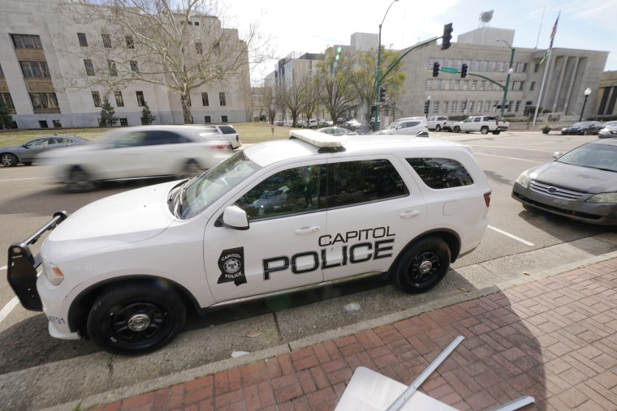

A Capitol Police SUV in downtown Jackson. Mississippi’s mostly white and mostly Republican Legislature is proposing to give Mississippi Capitol Police, which doesn’t answer to Jackson city officials, jurisdiction throughout the entire majority Black, majority Democratic city.Rogelio V. Solis / AP file

March 4, 2023, 3:00 AM PST

By [Jesse J. Holland](https://www.msnbc.com/author/jesse-j-holland-ncpn1294300), MSNBC Columnist

When [John Lewis of the Student Nonviolent Coordinating Committee](https://www.nbcnews.com/politics/congress/rep-john-lewis-lion-civil-rights-movement-dies-80-n1109176) and other civil rights activists defied tear gas and police beatings to cross the [Edmund Pettus Bridge](http://www.encyclopediaofalabama.org/article/h-2962) in Selma, Alabama, in 1965, they were marching *for* a voting rights act and *against* white Southerners who routinely resorted to violence, including bombings and murder, to ensure only white people would be in control of politics — even in [majority-Black towns such as Selma](https://www.historytoday.com/archive/feature/selma-and-civil-rights).

The president will be speaking in Selma as the political kin of those who made “Bloody Sunday” bloody employ legal maneuvers to control majority-Black cities.

[When President Joe Biden visits Selma on Sunday](https://apnews.com/article/biden-selma-a9344a78cd2fa68b5bac38392e4c900f), to commemorate what came to be known as “Bloody Sunday,” we shouldn’t think of him making just a typical nod to history. Because the president will be speaking in Selma as the political kin of those who made “Bloody Sunday” bloody employ legal maneuvers to control majority-Black cities.

They can’t totally stop Black people from voting, so they’ve decided to grant themselves the authority to render meaningless the choices Black voters make at the ballot box. The new strategy is to strip decision-making power away from the majority-Black residents of urban areas and give it to unelected white overlords from out of town.

Mississippi’s mostly white and mostly Republican Legislature is proposing to give [Mississippi Capitol Police](https://www.nbcnews.com/news/us-news/mississippi-capitol-police-jackson-shootings-rcna70474), which doesn’t answer to Jackson city officials, [jurisdiction throughout the entire majority Black, majority Democratic city](https://www.mississippifreepress.org/31048/state-run-capitol-polices-jurisdiction-would-cover-all-jackson-if-bill-becomes-law). In Missouri, the majority white and majority Republican Legislature is trying to use[a Civil War-era law to take St. Louis’ police force away from the city](https://missouriindependent.com/2023/01/10/state-control-of-kansas-citys-police-has-roots-in-the-civil-war/) and put it under state control. And in Washington, D.C., [the Republican-controlled U.S. House has voted to block the Washington City Council’s decision to update its crime code](https://www.nbcnews.com/politics/congress/house-votes-overturn-dc-voting-rights-crime-laws-rcna69976), an update that lowers maximum sentences for crimes that include carjacking and gun possession.

[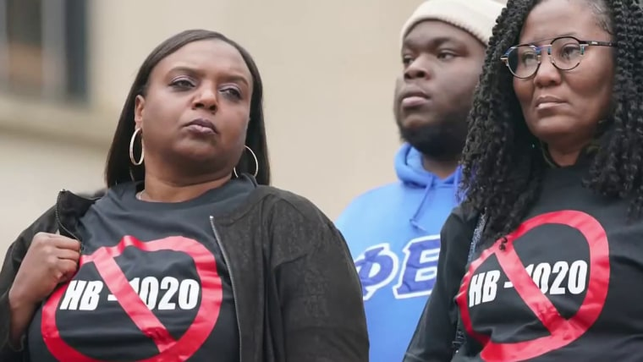](https://www.nbcnews.com/now/video/controversial-mississippi-state-court-system-bill-sparks-protest-164017221779)

[**Controversial Mississippi state court system bill sparks protest**](https://www.nbcnews.com/now/video/controversial-mississippi-state-court-system-bill-sparks-protest-164017221779)

FEB. 24, 202302:59

While he’s in Selma, Biden is likely to make yet another demand that the GOP-controlled House reauthorize the Voting Rights Act, but he should also use his time in that sacred space to call out these blatantly anti-democratic actions by white conservatives who are trying to reclaim their former apartheid-like power over Black people. But given [his announcement Thursday that he won’t veto a Congressional override of D.C.’s city council’s crime bill](https://www.nbcnews.com/politics/joe-biden/biden-wont-veto-republican-backed-bill-blocking-dc-crime-law-changes-rcna73082), Biden should ask himself how committed he himself is to the spirit of the Voting Rights Act.

Percentage-wise, Jackson is one of the Blackest cities in the country, which makes it all the more galling that last month, Mississippi’s Legislature flirted with [creating a separate court system and an expanded police force that would patrol all the city’s majority-white neighborhoods](https://mississippitoday.org/2023/02/07/jackson-court-system-house-bill-1020/) (and some other areas) and that [would be appointed exclusively by state officials who are white](https://mississippitoday.org/2023/02/23/senate-panel-strips-many-onerous-provisions-from-jackson-crime-bill/).  That plan preceded the current legislation which gives the Mississippi Capitol Police free rein throughout Jackson. Officers on that force have shot four people since August, and the force does not have to answer to Jackson residents or its outspoken Black mayor, the self-described radical Chokwe Antar Lumumba.

Biden should ask himself how committed he himself is to the spirit of the Voting Rights Act.

Lumumba is right to attribute the legislation to “plantation politics.” He recently told the Independent, “[If we allow this type of legislation to stand](https://www.independent.co.uk/news/world/americas/us-politics/ap-jackson-mississippi-capitol-police-chokwe-antar-lumumba-b2289887.html) in Jackson, Mississippi, it’s a matter of time before it will hit New Orleans, it’s a matter of time before it hits Detroit, or wherever we find our people.”

Except it’s already happening. Speaking of the Missouri’s Legislature’s gambit to take the police department from under her control, [St. Louis Mayor Tishaura Jones told The Intercept](https://theintercept.com/2023/02/24/st-louis-missouri-police-department/) that there’s a “common thread of the cities that I am aware of where this is happening. Where there has been a concerted attempt to strip power away from local leadership, the mayors are Black.”

According to the Missouri Independent, the state law that would be used to take away the St. Louis Police Department was conceived by a Civil-War-era governor who wanted Missouri to join the Confederacy and [sought control over what was then the state’s largest city](https://missouriindependent.com/2023/01/10/state-control-of-kansas-citys-police-has-roots-in-the-civil-war/).

[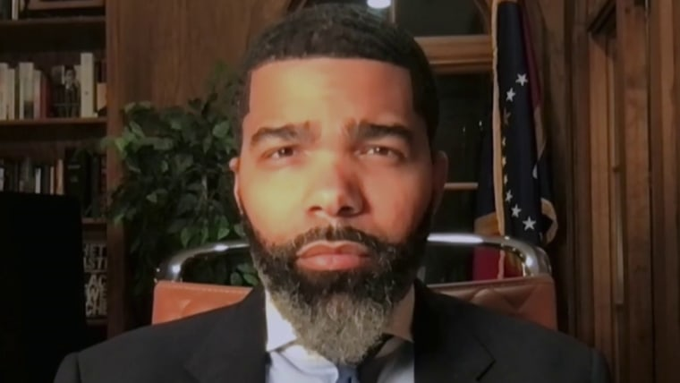](https://www.msnbc.com/the-reidout/watch/jackson-mississippi-mayor-chokwe-lumumba-on-white-officials-approving-bill-to-create-separate-white-appointed-court-system-for-80-percent-black-city-163306053551)

[**Jackson, MS mayor on bill to create separate white-appointed court system for majority-Black city**](https://www.msnbc.com/the-reidout/watch/jackson-mississippi-mayor-chokwe-lumumba-on-white-officials-approving-bill-to-create-separate-white-appointed-court-system-for-80-percent-black-city-163306053551)

FEB. 13, 202306:31

As for what's happening in Washington, Mayor Muriel Bowser vetoed the city's council update of its crime code and [has continued to oppose the change, even after the council overrode her veto](https://www.axios.com/local/washington-dc/2023/02/10/dc-mayor-congress-criminal-code-andrew-clyde). That's her right, but she still should have called out Congress for acting in a manner consistent with overseers and argued for D.C. residents' right to decide how their crime laws should look.

The Republicans behind these takeover bills cloak their anti-Black, anti-democratic actions by using the same buzzwords the tyrants in the Jim Crow South used: “public safety” and “citizens’ rights,” and they’re citing rising crime figures.

Is crime out of control in many cities? Yes. In Washington, there have been more than 200 murders in each of the last two years, and [an increased number of carjackings](https://www.axios.com/local/washington-dc/2023/01/04/dc-carjackings-rise-for-fifth-straight-year). An editorial from the St. Louis Post-Dispatch says that, last year, [St. Louis had the second-highest murder rate in the U.S](https://www.stltoday.com/opinion/editorial/editorial-missouri-gop-already-enables-gun-violence-now-it-wants-taxpayers-to-fund-more-of/article_89f5d397-68c4-5506-9007-72d2c1b3b2ca.html) behind New Orleans. But apparently, the newspaper's ranking only includes larger cities. Jackson, [according to a television news station there](https://www.wlbt.com/2023/01/07/analysis-second-straight-year-jacksons-homicide-rate-ranks-highest-us-among-major-cities/), ended 2022 with the highest homicide rate of any major city in the United States, with more than 130,000 people killed.

As awful as those statistics are, that’s why we have elections.

As awful as those statistics are, that’s why we have elections: When the people who live in these areas are dissatisfied with the work of their elected leaders and the effectiveness of the police, they can make their voices heard by voting them out.

**More from MSNBC Daily**

Must reads from Today's list

[](https://www.msnbc.com/opinion/msnbc-opinion/immigration-latino-republicans-attempt-impossible-rcna72754)

[HOLD THE LINE](https://www.msnbc.com/opinion/msnbc-opinion/immigration-latino-republicans-attempt-impossible-rcna72754)

[**The loneliest Republicans in Congress**](https://www.msnbc.com/opinion/msnbc-opinion/immigration-latino-republicans-attempt-impossible-rcna72754)

[Julio Ricardo Varela](https://www.msnbc.com/author/julio-ricardo-varela-ncpn297186)

[](https://www.msnbc.com/opinion/msnbc-opinion/fox-news-tucker-carlsons-jan-6-tapes-look-bad-dominion-made-worse-rcna73120)

[GOP GONE WILD](https://www.msnbc.com/opinion/msnbc-opinion/fox-news-tucker-carlsons-jan-6-tapes-look-bad-dominion-made-worse-rcna73120)

[**These Dominion bombshells make Kevin McCarthy — and Tucker Carlson — look even worse**](https://www.msnbc.com/opinion/msnbc-opinion/fox-news-tucker-carlsons-jan-6-tapes-look-bad-dominion-made-worse-rcna73120)

[Joyce Vance](https://www.msnbc.com/author/joyce-vance-ncpn1243130)

That’s the promise this country is supposed to stand for: Political leaders answer to the people they represent, and when a majority thinks the job isn't being done to its satisfaction, those leaders are voted out. That was why the Voting Rights Act existed in the first place, because white segregationists were refusing to let their Black constituents voice their disapproval of their segregationist tactics at the ballot box.

There’s a constant refrain from the GOP that Washington shouldn’t be telling Americans how to run their lives, but members of the same party either don’t see the contradiction or don’t care that they’re being hypocritical when they argue for outsiders taking control over Black cities.

President Biden is right to visit Selma, and he’ll be right to call for Congress to reauthorize the Voting Rights Act. But if he doesn’t also call out Republican actors for their naked attempts to take governing power away from Black people or take back his promise not to veto Congress bullying D.C., then he will have missed a real opportunity.

Last year, [Biden rightly called some Republican vote-suppression efforts Jim Crow 2.0](https://www.whitehouse.gov/briefing-room/speeches-remarks/2022/01/11/remarks-by-president-biden-on-protecting-the-right-to-vote/). It looks like version 3.0 is already in the works.

[Jesse J. Holland](https://www.msnbc.com/author/jesse-j-holland-ncpn1294300)

Jesse J. Holland, an award-winning author, professor and journalist, teaches journalism at the School of Media & Public Affairs at George Washington University and was a longtime congressional, Supreme Court and White House reporter with The Associated Press. He is the author of two African American history books about Washington, D.C., and has written for major entertainment franchises, including Lucasfilm’s "Star Wars," DC Comics’ "Superman" and Marvel’s "Black Panther."